Problem Statement: The CEO needs to get insight into the state of business in a dynamically growing company and needs data analyst to provide report dashboard rather than multiple excel files

AIMS grid:

Purpose: To unlock sales insight dynamically and automate some process to reduce manual time

Stake holders: Sales director, marketing and sales team, IT team, Data Analyst team.

End Result: Automated dashboard that provide quick and latest insight

Success criteria: Dashboard able to give insight based on update data.

Sales analyst stop manual data gathering and increase productivity.

* This is an end-to-end Data analysis project that produced a report that allows stake holders to consume information relating revenue and sales quantity
* Connected Power BI to MySQL and imported about 200K records. Performed data transformation in Power Query using GUI and M language.
* Other column calculations and creation of measures and parameters ware completed with DAX language in main Power BI platform
* Built dashboard in power BI from scratch that provide key insight on the fly

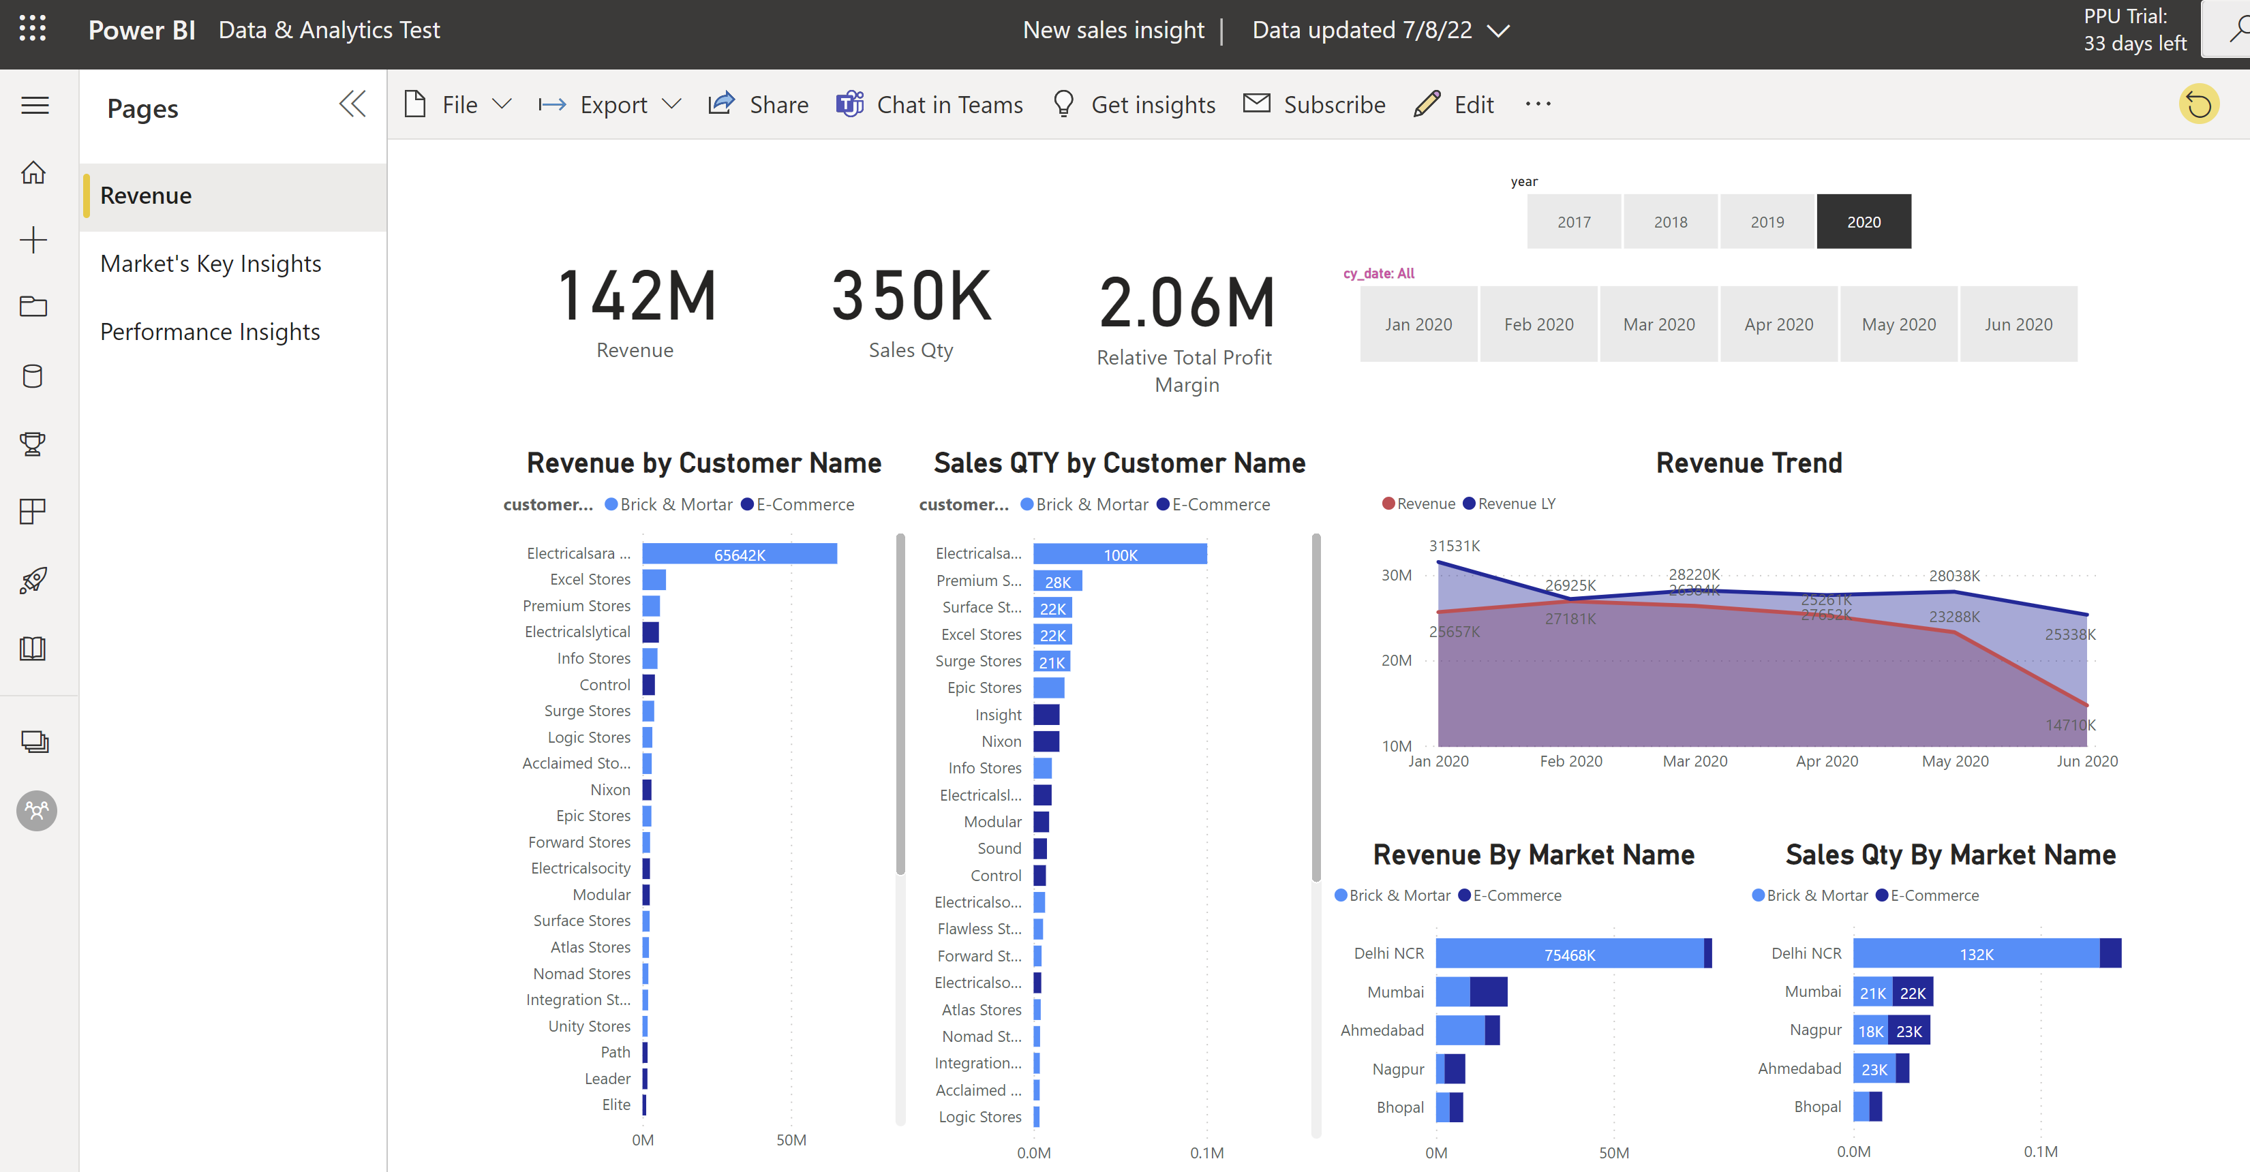

* This dashboard automatically gives the user information about top markets for revenue and profit margin contribution, therefore aiding transparency and proper decision making towards profitability. (Example: The strategy used in some markets with good profit margin could be looked into and replicated to other region)

